
Architecture Vision
Project XXXX
Client YYYY
<<Note: This document provides a generic template. It may require tailoring to suit a specific client and project situation.>>
Table of Contents
1 Purpose of this Document 3
2 Principle Template 4
3 Summary of Principles 5
4 Business Principles 6
5 Data Principles 7
6 Application Principles 8
7 Technology Principles 9

Document Information
Project Name: | Project XXX
Prepared By: |  | Document Version No: | 0.1
Title: | Architecture Vision | Document Version Date:
Reviewed By: |  | Review Date:
Distribution List
From | Date | Phone/Fax/Email

To | Action* | Due Date | Phone/Fax/Email
* Action Types: Approve, Review, Inform, File, Action Required, Attend Meeting, Other (please specify)
Document Version History
Version  Number | Version  Date | Revised By | Description | Filename

Purpose of this Document
The Architecture Vision is created early on in the project lifecycle and provides a high-level, aspirational view of the end architecture product. The purpose of the vision is to agree at the outset what the desired outcome should be for the architecture, so that architects can then focus on the critical areas to validate feasibility. Providing an Architecture Vision also supports stakeholder communication by providing an executive summary version of the full Architecture Definition.
It may be that the Architecture Vision is documented using a wiki or as an intranet rather than a text-based document. Even better would be to use a licensed TOGAF tool that captures this output.
This template shows “typical” contents of an Architecture Vision and can be adapted to align with any TOGAF adaptation being implemented.

Problem Description

Stakeholders and their Concerns
SGLines as a shipping company has huge diversity throughout the organisation that span across the globe. Their businesses run at the global scale that covers from States throughout the Asia regions. Although with huge coverage of businesses, SGLines doesn’t possess a good flow information from one department to another, not to mention a traditional way of process sales, which prone to human errors.
Further elaboration of the stakeholders and their concern is mapped through below table
Stakeholder | Key Concern
Customer | Ability to place order with higher turn around date
CxO | Losing sales? Prevent delay of shipment errors, Higher SLA, Cutting cost
Sales Team | Real time sales order generation, and faster feedback from RFQ, Improve Up time for VMS and CMS, at the same time improve customer service level through usage of technology
Order Processing Team | To have real time checking on vessel availability and container availability
IT and Operations | Sceptical on the investment of the new IT business goals, as they have no confident on the new system and technologies
Container Management Team | To have better recorded network with tow head operator, and hope could improve the efficiency of the local tow head operators. Current operation take too long to query a certain information from local tow head operator

List of Issues/Scenarios to be Addressed
Through the initial study of SGLines business flow, the team manage to identify issues and scenarios to be addressed as per below
- Reduce the operation cost of SGLines
- Losing of sales due to unanswered call from customer
- Consolidation of multiple systems based on the business domain to improve real time access
- Accurate Real time information throughout multiple departments
- Improve UP TIME for system that classified as critical
- Improve response time to customer

<<The purpose of this section is to define the business context and problem description for which the vision of the target architecture has been produced.
Mandatory/optional: This section is mandatory.
In terms of quality criteria, this section should make clear:
a. Business vision statement for the target architecture
b. Pictorial representation of business context
c. Change drivers and opportunities behind this vision for the target architecture>>

Business Vision Statement
With the planned improvement by restructuring and reorganising the processes and work flow of the organisation, SGLines shall have significant(should this be figure?) improvement in terms of revenue and operating profit. Not to mention, with the help of modularity within department and better process work flow to achieve instant shared services / Information across multiple department within in bound and out bound of the organisation that will move to better customer care services
The target architecture must be able to support and improve current SGLines business operation

<<The purpose of this section is to define the business vision statement of the target architecture.
Mandatory/optional: This section is mandatory.
In terms of quality criteria, this section should make clear:
a. Business vision statement(s) for the target architecture>>

Business Vision Diagram
WIP CHANG FENG

<<The purpose of this section is to provide one or more suitable pictorial representation(s) that explain the business context and business problem. They are required in order to obtain senior executive engagement with this activity.
Mandatory/optional: This section is optional but recommended.
In terms of quality criteria, this section should make clear:
a. Diagram(s) explaining the problem statement for the target architecture
b. Description of business vision diagram>>

Change Drivers & Opportunities
After years of operation, SGLines is in dire needs to revamp the current flow of the processes that often considered as un-competitive to serve the day to day operation needs. After further analysis of current workflow of SGLines, it is obvious that the company suffer from losses from time to time due to human error and dependencies. There is a huge gap of communication within department that cause such issue and in turn drive them to lose of sales and revenue, not to mention mistakes done could lead to liquidated damages the company has to suffer. To summarise in better detail, the main drivers and opportunities for changes is as per below
- Increase Operation Profit, SGLines predicted decline of sales up to 40% for years ahead due to global economic recession. Declining of sales must be compensated with better operation cost to minimises the losses and help the company to be more efficient in managing their internal workflow
- Traceability of cost, network, and shipping movement is another main event that SGLines must be able to trace the cost of engagement for each local tow head operators. At corporate level, this is an important factor, rather than depending on the bulk cost summary, an itemised billing based on the distance of travel would have better impact on setting up the routes they should take.
- Losses of sales revenue due to unentertained customer has been a common scenario when sales staff is too occupied with other task
- Usage of ecommerce portal as point of sales is another factor to retain the customer.
- Cluttered business process flow which in turn lead to uncertain turnaround time to present the available information to customer
- Underutilized computer resources, with the hope of salvaging the current resources and put it into a good use
- Poor support of current IT structure which in turn lead to poor system availability and capability to have desired further enhancement to support daily business needs.
- Information availability and readiness across different inbound and outbound departments.
- Service Oriented Architecture that stresses on standard mean of communication between different systems to assist in better flow of information across different systems
- Use of standard interface data format to ensure all data interchange format is easily adopted by different vendor and other third party system that wish to communicate with SGLines internal system

<<The purpose of section is to identify the change drivers and opportunities behind this vision for the target architecture.
Mandatory/optional: This section is mandatory.
In terms of quality criteria, this section should make clear:
a. Change drivers that will impact decisions made for the target architecture
b. Opportunities that can be leveraged for the target architecture>>

Detailed Objectives
With the above Issue and change drives, SGLines shall adopt few business objectives to resolve the issue in effective manner.
- Increase the Operating Profit by 25% annualy
- Speed up the sales process from 3 working days to 1 day
- Minimise loss of customer due to unanswered call by 70%
- Reduce the cost of local shipping containers by 50%
- Improve the system availability by 99.9%

As from technology point of view , it is best for SGLines to remove those unsupported legacy system and at the same time merging systems from similar domain to achieve uniformity in terms of information flow and at the same time improve the efficiency of the work flow.
Technology objectives
- Archive modularity for every system
- Decommissioning SOS
- Bring in COTS for less business critical system
- Adopt SOA and ensure the capability of ESB
- Enterprise level system for different service enablement.

<<The purpose of this section is to describe the detailed objectives that need to be fulfilled by the target architecture. The previous section looks at the business problem, whereas this section determines the objectives, for the architecture solution, that will resolve the business problem.
Mandatory/optional: This section is mandatory.
In terms of quality criteria, this section should make clear:
a. Business objectives to resolve the business problem
b. Technology objectives, such as decommissioning>>

Environment and Process Models
Further on the planning of SGLines EA blue print, the company direction is to scrutinise the cluttered process model where there are too many unnecessary steps that cause delay in timing, role duplication and inaccurate information. This has casue a lot of losses in term of monetary to SGLines, not to mention lead to poor customer satisfaction on the service provided by SGLines.
The Ideal processes flow for SGLines would be to minimise the effort of each staff , improve the response time and information readiness thus will lead to better efficiency in resource utilisation (be it human or non-human resources). The new process flow will consist of
- Global Sales , where it handle all the sales from internal staff or external customer
- Space Tracing ¸ for vessel and container availability with the predefined routes and calculation of the most effective cost
- Global Payment , that handle the payment from customer and billing from third party vendors. The process will handle in multiple currency
- Shipment Tracking to ensure the success and prevent losses of every delivery, every customer item will be tagged with specialised identification, where it can be used to track the location of the item, which container and scheduled departure from and arrival to date .

Diagram ::

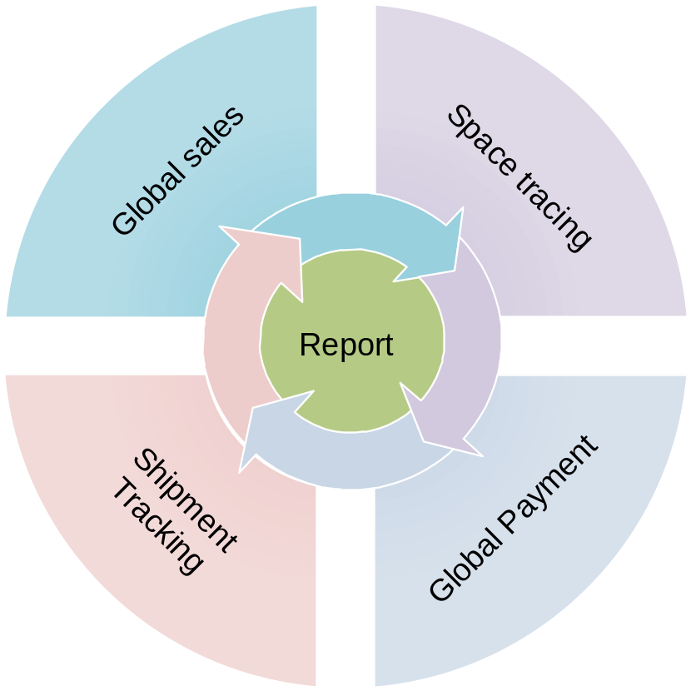

Most of the business process in SGLines need to have accompanying technology and business environment to support the activity
Business Process | Environment |  | User Group
Business Process | Business | Technology | User Group
Global Sales | - Customer  - Client  - Sales Personnel  - Competitor | - Sales ordering system  - Sales portal | - Sales Process Team  - Order Process team
Space Tracing | - Customer  - Client  - Local tow head  - Country rules and regulation | - Vessel and Contrainer managmenet  - Prediction engine | - Container management Team
Global Payment | - Customer  - Client  - Bank Merchant  - Rules and regulation  - Currency Exchange rate | - Global payment portal  - Account management | - Bank Merchant  - Order Processing Team
Shipment Tracking | - Port Rules and regulation  - Customer / client  - Local tow head operator | - ShipTrack system | - Container management Team
Reporting | - All other business proceses | - Reporting Tools | - Senior / top level management

Information Flow
With the above explanation, SG lines is divided into 5 different processes, Each process will trigger the next processes sequentially through the successive chain of information transfer from 1 process to another.
The steady flow of information is critical and need to be identified early to ensure there are no hiccup along the while process flow. Below is the further explanation of the steady flow of information in detail
- The initial state is the information from customer or client that requested to ship and item based on the weight, size, and custom declaration of the items. Every information will go through Global Sales process before it is escalated further for space tracing
- Space tracing is when user have submitted required information and need to have arrangement on the vessel and shipping confirmation. This process should took less than a day
- Once everything is completed and user is agree with the routes, they will proceed with the payment through the Sales order generated by Global Sales process. The order will indicate the detail of the items and the total purchase prices in multiple currency
- Last Flow of the information would be the tracking of the shipment. Through payment SGLines will trigger tow head operator on the incoming request. The request will be handled by the tow head operator and processed accordingly. The information on current status of the item will be updated regularly by tow head operators

<<The purpose of this section is to outline the environment and process models that are in scope for the target architecture.
Mandatory/optional: This section is mandatory.
In terms of quality criteria, this section should make clear:
a. Business processes that are in scope for the vision
b. Business and technology environment in scope for the vision
c. Users who interact with the business process
d. Information flows for the business processes>>

Process Description
<<The purpose of this section is to outline the business processes that are in scope and thus impacted by the target architecture.
Mandatory/optional: This section is mandatory.
In terms of quality criteria, this section should make clear:
a. Business processes that are in scope for the vision
b. If required, high-level diagram(s) of business processes
c. Descriptions for the business process diagrams>>

Process Steps Mapped to Environment
<<The purpose of this section is to cross-reference the business processes, in scope, to the business and technology environments.
Mandatory/optional: This section is mandatory.
In terms of quality criteria, this section should make clear:
a. Business environment in scope for the vision
b. Technology environment in scope for the vision>>

Process Steps Mapped to People
<<The purpose of this section is to cross-reference the business processes to business actors; i.e., business users. Business actors/users are those users who interact with a business process.
Mandatory/optional: This section is mandatory.
In terms of quality criteria, this section should make clear:
a. Business users involved with the business processes in scope>>

Information Flow
<<The purpose of this section is to describe the information flows that correspond to the business processes in scope for the target architecture.
Mandatory/optional: This section is mandatory.
In terms of quality criteria, this section should make clear:
a. Information flows for the business processes in scope>>

Actors and their Roles and Responsibilities

<<The purpose of this section is to describe the system users/actors in scope for the target architecture. System actors/users are those users who interact with a system. They can be human or a system/computer.
Mandatory/optional: This section is mandatory.
In terms of quality criteria, this section should make clear:
a. Human (system) actors and roles in scope for the target architecture
b. Computer (system) actors and roles in scope for target architecture
c. Any other system actor-oriented requirements in scope for the target architecture>>

Human Actors and Roles
Actor | Role
Sales Team | - Process the incoming sales  - Help with order realisation between customer and SGLines
Order Process team | - Carry forward the task of sales team  - Generate purchase order and bill the customer
Container Management Team | - Maintain close relation with local horizon office  - Manage Vessel and container scheduler and space
Web User | - Adhoc User that purchase shipping service
CxO | - Manage overall SGLines direction
IT Support | - Provide 8/5 IT support to the system  - Maintain report batch timing to be generated by the system

<<The purpose of this section is to define the human actors and roles in scope for the target architecture.
Mandatory/optional: This section is mandatory.
In terms of quality criteria, this section should make clear:
a. Human actors and roles in scope for the target architecture>>

Computer Actors and Roles

Actor | Role
SCBS | - Process sales  - Process payment  - Process PO generation
VCMS | - Manage Vessel schedule  - Manage Container Schedule  - Advance analytics and prediction engine  - Maintain local tow head operators with the cost
Shipment Tracking | - Track client shipment process
SGLines Website | - Serve as static FAQ of the company  - Allow purchasing of SGLines service  - Allow preview of shipment tracking
Interface Engine | - Act as separate entity that publish web service Interfaces to other company
AFIS | - Act as SGLines internal account and financial system
HRS | - Act as internal Human Resource Sytem
Report | - Business intelligent reporting tools that extract data form Data Warehouse
Data Warehouse | - Store and process the data from different system. Act as Single source of truth among system communication  - Only track pertaining report and Interface Engine

<<The purpose of this section is to define the computer actors and roles in scope for target architecture.
Mandatory/optional: This section is mandatory.
In terms of quality criteria, this section should make clear:
a. Computer actors and roles in scope for target architecture>>

Requirements
Although most of the process flow can be automated, there are still minor gaps that need human intervention to ensure the successful run on the target architecture
- To Establish better network of local tow head operators and companies, the internal team should perform any necessary lookup and keep the record into the system for internal cost calculation
- Web Order that does not get processed due to the insufficient space or long vessel duration, the sales team shall help to locate an appropriate places by convincing the user on their action and decision

<<The purpose of this section is to define any other actor-oriented requirements in scope for the target architecture.
Mandatory/optional: This section is mandatory.
In terms of quality criteria, this section should make clear:
a. Any other actor-oriented requirements in scope for the target architecture>>

Resulting Architecture Model
The proposed architecture model is based on SOA approach, this is to ensure future extension for different of other application that wish to be part of the ecosystem.
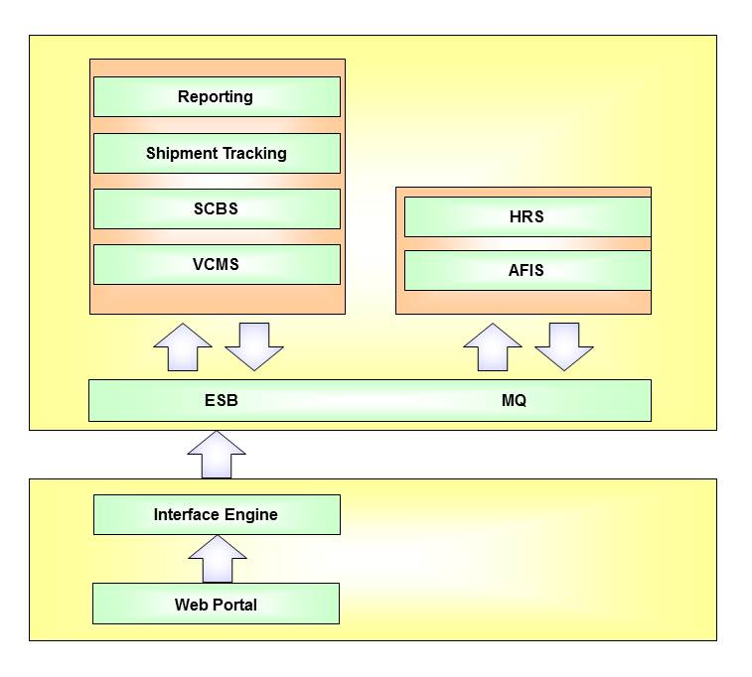

As per diagram above the system will ensure communication through the ESB channel that help to route the message from one system to another. However, if there is any mean of non-intranet communication, they must go through the intended publisher, where message exchange will be performed through agreeable secured protocol and channel.

<<The purpose of this section is to describe the target architecture.
Mandatory/optional: This section is mandatory.
In terms of quality criteria, this section should make clear:
a. High-level diagram(s) of the target architecture
b. Description of the diagram(s)
c. Requirements that map onto the target architecture
d. Constraints that impact the target architecture
e. Principles that can be leveraged in order to define the target architecture>>

Constraints
With the proposed implementation of target architecture, there will be constrains that imposed either implicitly or explicitly by SGLines organisation. These constraints will have direct impact on the quality of the solution and must be identify and if possible early mitigation plan should be addressed to ensure smooth transitioning from the base line to the target architecture. Below are the identified constraints
- Staff skill set is one of the important factor that ensure smooth transitioning, not to mention with the introduction of new technology, the staff must have the knowledge to handle the implementation.
- Transition period for critical system, As certain system such as VMS and CMS is classified as mission critical, therefor, initial migration for the system should take the least amount of time as possible
- Infrastructure capability is another set of important criteria where detail assessment on the current infrastructure is capable enough to handle the new ecosystem. This will play major factor in terms of speed of operation
- Information exchange between local horizon office, as these offices might use different environment and system, the message interchange must follow a world standard protocol for logistic data exchange
- Internal Politics such as unwilling corporation from different level of people has always been a major hurdle for EA implementation. This should be done through higher authority level.
- Budgeting, SGLines need to be transparent on the resources they are willing to spend. As with the information given, SGLines should be able to plan and prioritise the component for migration towards the new Architecture.

<<The purpose of this section is to describe the constraints that impact the target architecture.
Mandatory/optional: This section is mandatory if constraints need to be taken into consideration.
In terms of quality criteria, this section should make clear:
a. Constraints that impact the target architecture>>

IT Principles
SGLines has set of principles that they wish to follow and retain even with the implementation of the new target architecture. The principles will help to refine further on “do and don’ts” and will help to ensure the shaping of the new target architechture.
- Availability of the system throughout the year with minimum level of unscheduled down time
- Separation of concerns between different layer of each application
- Standardisation of security rules and protocols for their internal staff
- Security audit that must be enforced for internal staff an every supporting application.
- Disaster Recovery and HA , is another part of the new principles SGLines wish to have as this to ensure to prevent data and business losses due to down time.

<<The purpose of this section is to describe the principles that can be leveraged in order to define the target architecture.
Mandatory/optional: This section is mandatory if existing principles need to be taken into consideration.
In terms of quality criteria, this section should make clear:
a. Principles that can be leveraged in order to define the target architecture>>

Architecture Supporting the Process
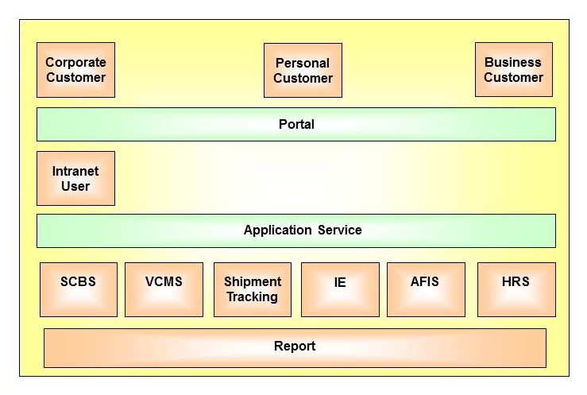
Based on the proposed target architecture as per above, SGLines business flow shall be supported by the list of available Architecture. Within the diagram, SGLines usecases is divided into 3 different domain, Which is the
- External User that consist of Corporate customer, business customer, or personal customer that wish to use SGLines shipping services
- Intranet User is the SGLines internal staff that perform daily task to help with SGLines business
- Application Services is the list of application that help SGLines business flow

<<The purpose of this section is to describe the target architecture.
Mandatory/optional: This section is mandatory.
In terms of quality criteria, this section should make clear:
a. High-level diagram(s) of the target architecture
b. Description of the diagram(s)>>

Requirements Mapped to Architecture
Discuss with the rest
<<The purpose of this section is to describe the high-level business and technology requirements that map onto the target architecture.
Mandatory/optional: This section is mandatory.
In terms of quality criteria, this section should make clear:
a. Existing business requirements such as goals and objectives that map onto the target architecture
b. Existing technology requirements that map onto the target architecture>>

End Vision Statement
<<A statement executive summary of the end vision of the architectural effort.
Begin with the end in mind!>>

